**COMPUTER**

**SCIENCE PROJECT**

(Session: 2020-2021)

**Topic:** An application of writing and reading with

a feature of chatting with bot.

Guided by : Made by:

Rekha Saraswat Aditi Ozardekar

ma'am BhushitJaisawal

Pragati Kulshreshtha

Class: XII A

**Acknowledgment**

I would like to convey my thanks to our Principal, Mr.

P.Dhanasekaran , Lions English School, Silvassa for

providing opportunity of making this project.

I would also like to thank Mrs. Rekha Saraswat , my

Computer Teacher , Lions English School, Silvassa for

Her guidance and support .

I would also like to thank my teammates who devoted their time and efforts in the project

**INDEX**

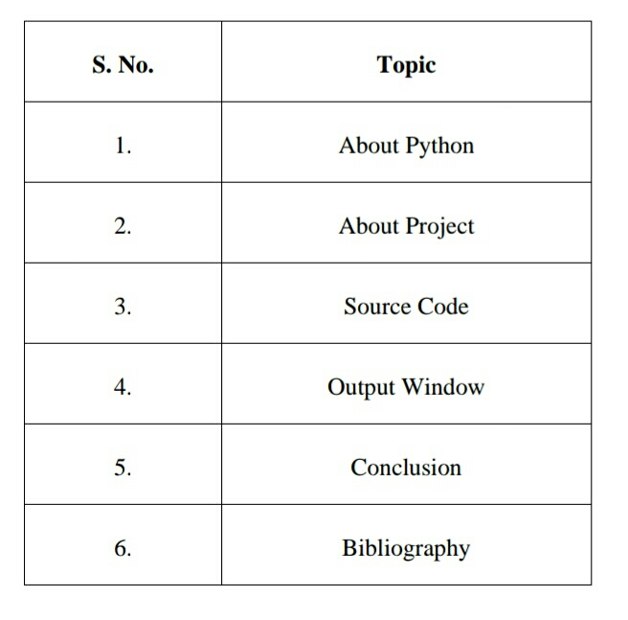

**ABOUT PYTHON**

Python is an interpreted, object-oriented, high-level programming language with dynamic semantics. Its high-level built in data structures, combined with dynamic typing and dynamic binding, make it very attractive for Rapid Application Development, as well as for use as a scripting or glue language to connect existing components together. Python's simple, easy to learn syntax emphasizes readability and therefore reduces the cost of program maintenance. Python supports modules and packages, which encourages program modularity and code reuse. The Python interpreter and the extensive standard library are available in source or binary form without charge for all major platforms, and can be freely distributed.

**ABOUT PROJECT**

The project creating an application for writing and reading with a feature chatting with BOT(basic) provides the user to access three different kinds of feature in just one application. The application is created based upon many people’s hobby of reading books and writing their own thoughts .

The user can write whatever they wish to and read different kinds of books and also can have the conversation with BOT in the same app by using the chatting feature (with Bot).

This application is created by using modules like tkinter , python , MySQL.connector which gives the user a great experience of writing , reading and chatting (with bot).

SOURCE CODE

from tkinter import *

from tkinter import ttk

from tkinter.filedialog import asksaveasfile

from tkinter.filedialog import askopenfile

from tkinter import messagebox

import mysql.connector as sq

#function for chatting window

def chat():

root=Tk()

root["bg"]="black"

def send():

send="You => "+e.get("1.0","end-1c")

txt.insert(END,"\n"+send)

if (e.get("1.0","end-1c")=="hello"):

txt.insert(END,"\n"+"Bot => hi")

elif(e.get("1.0","end-1c")=="hi"):

txt.insert(END,"\n"+"Bot => hello")

elif(e.get("1.0","end-1c")=="how are you"):

txt.insert(END,"\n"+"Bot => I'm fine ")

else:

txt.insert(END,"\n"+"Bot=> sorry i didn't get")

e.delete("0.0",END)

txt=Text(root,height=10,width=50,bg="light slate grey")

txt.grid(row=0,column=0,columnspan=2)

e=Text(root,height=5,width=30,bg="sandy brown")

e.grid(row=1,column=0)

send=Button(root,text="Send",bg="turquoise",activebackground="dark green",command=send)

send.grid(row=1,column=1)

root.title("Chatbot")

def aa():

top = Tk()

sb = Scrollbar(top)

sb.pack(side = RIGHT, fill = Y)

mylist = Listbox(top,height=1366,width=768,font=('Times New Roman','20'), yscrollcommand = sb.set )

f=open("aa.txt",'r')

x=f.readlines()

for line in x:

mylist.insert(END, str(line))

mylist.pack( side = LEFT )

sb.config( command = mylist.yview )

def bb():

top=Tk()

sb=Scrollbar(top)

sb.pack(side=RIGHT,fill=Y)

mylist=Listbox(top,height=1366,width=768,font=('Times New Roman','20'),yscrollcommand=sb.set)

f=open("bb.txt",'r')

x=f.readlines()

for line in x:

mylist.insert(END, str(line))

mylist.pack( side = LEFT )

sb.config( command = mylist.yview )

def cc():

top = Tk()

sb = Scrollbar(top)

sb.pack(side = RIGHT, fill = Y)

mylist = Listbox(top,height=1366,width=768,font=('Times New Roman','20'), yscrollcommand = sb.set )

f=open("cc.txt",'r')

x=f.readlines()

for line in x:

mylist.insert(END, str(line))

mylist.pack( side = LEFT )

sb.config( command = mylist.yview )

def dd():

top = Tk()

sb = Scrollbar(top)

sb.pack(side = RIGHT, fill = Y)

mylist = Listbox(top,height=1366,width=768,font=('Times New Roman','20'), yscrollcommand = sb.set )

f=open("dd.txt",'r')

x=f.readlines()

for line in x:

mylist.insert(END, str(line))

mylist.pack( side = LEFT )

sb.config( command = mylist.yview )

def ee():

top = Tk()

sb = Scrollbar(top)

sb.pack(side = RIGHT, fill = Y)

mylist = Listbox(top,height=1366,width=768,font=('Times New Roman','20'), yscrollcommand = sb.set )

f=open("ee.txt",'r')

x=f.readlines()

for line in x:

mylist.insert(END, str(line))

mylist.pack( side = LEFT )

sb.config( command = mylist.yview )

def ff():

top = Tk()

sb = Scrollbar(top)

sb.pack(side = RIGHT, fill = Y)

mylist = Listbox(top,height=1366,width=768,font=('Times New Roman','20'), yscrollcommand = sb.set )

f=open("ff.txt",'r')

x=f.readlines()

for line in x:

mylist.insert(END, str(line))

mylist.pack( side = LEFT )

sb.config( command = mylist.yview )

def gg():

top = Tk()

sb = Scrollbar(top)

sb.pack(side = RIGHT, fill = Y)

mylist = Listbox(top,height=1366,width=768,font=('Times New Roman','20'), yscrollcommand = sb.set )

f=open("gg.txt",'r')

x=f.readlines()

for line in x:

mylist.insert(END, str(line))

mylist.pack( side = LEFT )

sb.config( command = mylist.yview )

def hh():

top = Tk()

sb = Scrollbar(top)

sb.pack(side = RIGHT, fill = Y)

mylist = Listbox(top,height=1366,width=768,font=('Times New Roman','20'), yscrollcommand = sb.set )

f=open("hh.txt",'r')

x=f.readlines()

for line in x:

mylist.insert(END, str(line))

mylist.pack( side = LEFT )

sb.config( command = mylist.yview )

def ii():

top = Tk()

sb = Scrollbar(top)

sb.pack(side = RIGHT, fill = Y)

mylist = Listbox(top,height=1366,width=768,font=('Times New Roman','20'), yscrollcommand = sb.set )

f=open("ii.txt",'r')

x=f.readlines()

for line in x:

mylist.insert(END, str(line))

mylist.pack( side = LEFT )

sb.config( command = mylist.yview )

def jj():

top = Tk()

sb = Scrollbar(top)

sb.pack(side = RIGHT, fill = Y)

mylist = Listbox(top,height=1366,width=768,font=('Times New Roman','20'), yscrollcommand = sb.set )

f=open("jj.txt",'r')

x=f.readlines()

for line in x:

mylist.insert(END, str(line))

mylist.pack( side = LEFT )

sb.config( command = mylist.yview )

def kk():

top = Tk()

sb = Scrollbar(top)

sb.pack(side = RIGHT, fill = Y)

mylist = Listbox(top,height=1366,width=768,font=('Times New Roman','20'), yscrollcommand = sb.set )

f=open("kk.txt",'r')

x=f.readlines()

for line in x:

mylist.insert(END, str(line))

mylist.pack( side = LEFT )

sb.config( command = mylist.yview )

def ll():

top = Tk()

sb = Scrollbar(top)

sb.pack(side = RIGHT, fill = Y)

mylist = Listbox(top,height=1366,width=768,font=('Times New Roman','20'), yscrollcommand = sb.set )

f=open("ll.txt",'r')

x=f.readlines()

for line in x:

mylist.insert(END, str(line))

mylist.pack( side = LEFT )

sb.config( command = mylist.yview )

#function for showing books in adventures books

def w11():

master=Tk()

master.title("adventures books")

master["bg"]="black"

Label(master,text="adventure books:",bg="black",fg="beige").pack()

Button(master,text="1.The Weeding Date",fg="medium orchid",command=jj).pack()

Label(master,text="\n",bg="black").pack()

Button(master,text="2.The Heart Of Darkness",fg="medium orchid",command=kk).pack()

Label(master,text="\n",bg="black").pack()

Button(master,text="3.The Other Side Of Midnight",fg="medium orchid",command=ll).pack()

#function for showing books in horror books

def w10():

master=Tk()

master.title("horror books")

master["bg"]="black"

Label(master,text="horror books:",bg="black",fg="beige").pack()

Button(master,text="1.The Good Indians",fg="orange red",command=gg).pack()

Label(master,text="\n",bg="black").pack()

Button(master,text="2.Tarzan Of The Apes",fg="orange red",command=hh).pack()

Label(master,text="\n",bg="black").pack()

Button(master,text="3.Moby Dick",fg="orange red",command=ii).pack()

#function for showing books in romantic books

def w9():

master=Tk()

master.title("romantic books")

master["bg"]="black"

Label(master,text="romantic books:",bg="black",fg="beige").pack()

Button(master,text="1.The Proposal",fg="hot pink",command=dd).pack()

Label(master,text="\n",bg="black").pack()

Button(master,text="2.The Hating Game",fg="hot pink",command=ee).pack()

Label(master,text="\n",bg="black").pack()

Button(master,text="3. Mexican Gothic",fg="hot pink",command=ff).pack()

#function for showing books in fictional books

def w8():

master=Tk()

master["bg"]="black"

master.title("fictional books")

Label(master,text="fictional books:",bg="black",fg="beige").pack()

Button(master,text="1.Time Machine Tales",fg="indianred",command=aa).pack()

Label(master,text="\n",bg="black").pack()

Button(master,text="2.David Lodge",fg="indianred",command=bb).pack()

Label(master,text="\n",bg="black").pack()

Button(master,text="3.Blood Thirst 100",fg="indianred",command=cc).pack()

def submit():

messagebox.showinfo(" ","Book will be added within a week \n if available ")

#function for suggestion from the user of adding a book

def add():

master=Tk()

book_name=StringVar()

author_name=StringVar()

global e4

global e5

Label(master,text="BOOK NAME:").pack()

e4=Entry(master,textvariable=book_name)

e4.pack()

Label(master,text="AUTHOR'S NAME:").pack()

e5=Entry(master,textvariable=author_name)

e5.pack()

Button(master,text="SUBMIT",command=submit).pack(side="bottom")

#function for reading section

def w7():

master=Tk()

master.title("Reading section")

master["bg"]="black"

x="WELCOME TO THE READING SECTION"

Label(master,text=x,bg="black", fg="beige").pack()

Label(master,text="categories of books:",bg="black",fg="beige").pack()

Label(master,text="\n",bg="black").pack()

Button(master,text="FICTIONAL",fg="indianred",command=w8).pack()

Label(master,text="\n",bg="black").pack()

Button(master,text="ROMANTIC",fg="hot pink",command=w9).pack()

Label(master,text="\n",bg="black").pack()

Button(master,text="HORROR",fg="orange red",command=w10).pack()

Label(master,text="\n",bg="black").pack()

Button(master,text="ADVENTURE",fg="medium orchid",command=w11).pack()

Label(master,text="Want any book to be added...click on the button given above:").pack(side="bottom")

Button(master,text="Add book +",command=add).pack(side="bottom")

#function for saving a file

def w6():

g=text.get("1.0", "end-1c")

files = [('All Files', '.'), ('Python Files', '.py'),

('Text Document', '.txt')]

file = asksaveasfile(initialfile="Untitled.txt",filetypes = files, defaultextension = ".txt")

file.write(g)

#function for opening a file

def w5():

file = askopenfile(defaultextension=".txt",filetypes=[("All Files",".*"),("Text Documents",".txt"),("Python Files",".py")])

for c in file:

text.delete("0.0",END)

text.insert(END,c)

def w4():

global top

top=Tk()

global text

text=Text(top)

text.pack()

menubar=Menu(top)

file=Menu(menubar,tearoff=0)

file.add_command(label="open",

command=w5)

file.add_command(label="save",command=w6)

menubar.add_cascade(label="File",menu=file)

top.configure(menu=menubar)

#function for writing section

def w3():

global master

master=Tk()

master.title("Writing section")

master["bg"]="black"

Label(master,text='WELCOME TO THE WRITING SECTION!\n\n ---write your personal thoughts',bg='black',fg='dark turquoise',font=('Arail Bold',"15")).pack()

Button(master,text="start writing >",fg="salmon",command=w4).pack(side="bottom")

def call_info():

x="\n This is an application of writing and reading..with a feature of chatting(with Bot) . \n this application is based upon the hobbies of most of the people."

Label(window,text=x,bg="black",fg="beige",font=("Times New Roman","16")).pack()

#function for information window

def info():

global window

window=Tk()

window.title("Info")

window["bg"]="black"

window.geometry("200x150")

Button(window,text="info",bg="black",fg="beige",command=call_info).pack()

#function for menu window of the application

def w2():

messagebox.showinfo("log in","you have log in successfully!")

con=sq.connect(host="localhost",user="root",passwd="password",database="details")

cur=con.cursor()

cur.execute("INSERT INTO info(fullname,dateofbirth,gender,password)VALUES('%s','%s','%s','%s','%s')" %(e1.get(),e2.get(),e3.get(),e4.get()))

con.commit()

con.close()

master= Tk()

master.title("login")

master['bg']='black'

master.geometry('600x400')

Button(master,text="WRITING",bg="black",fg="lawn green",height=6,width=20,command=w3).pack()

Label(master,text="\n",bg="black").pack()

Button(master,text="READING",bg="black",fg="lawn green",height=6,width=20,command=w7).pack()

Label(master,text="\n",bg="black").pack()

Button(master,text="CHATTING",bg="black",fg="lawn green",height=6,width=20,command=chat).pack()

Button(master,text="•••",bg="black",fg="White",command=info).place(relx=1.0,y=0,anchor="ne")

#function for sign up window

def w1():

master=Tk()

master.title("Sign Up")

master['bg']='black'

master.geometry('600x400')

full_name_var=StringVar()

dob_var=StringVar()

gender_var=StringVar()

password_var=StringVar()

global e1

global e2

global e3

global e4

l1=Label(master,text=" FULL NAME:",bg='black',fg="lemon chiffon")

l1.pack()

e1=Entry(master,textvariable=full_name_var)

e1.pack()

l2=Label(master,text="DATE OF BIRTH:",bg='black',fg="lemon chiffon")

l2.pack()

e2=Entry(master,textvariable=dob_var)

e2.pack()

l3=Label(master,text="GENDER:",bg="black",fg="lemon chiffon")

l3.pack()

e3=Entry(master,textvariable=gender_var)

e3.pack()

l4=Label(master,text="PASSWORD:",bg="black",fg="lemon chiffon")

l4.pack()

e4=Entry(master,textvariable=password_var,show="*")

e4.pack()

Button(master,text="Log In",bg="sky blue",activebackground="dark blue",command=w2).pack(side="bottom")

#mainloop program

root=Tk()

root.geometry('600x400')

root.title("Welcome window")

root['bg']='black'

x="WELCOME TO THE WORLD OF\nWRITING AND READING \n \n -------with an added feature of chatting(withBot)"

a=Label(root,text=x,bg='black',fg='white',font=("Times New Roman","24"))

a.pack()

Button(root,text="QUIT",command=root.quit,width=6,fg='red',activebackground="red").pack(side="bottom")

Button(root,text="NEXT : >",fg='dark blue',width=8,activebackground="dark blue",command=w1).pack(side="bottom")

root.mainloop()

**OUTPUT WINDOWS**

* **Welcome window**

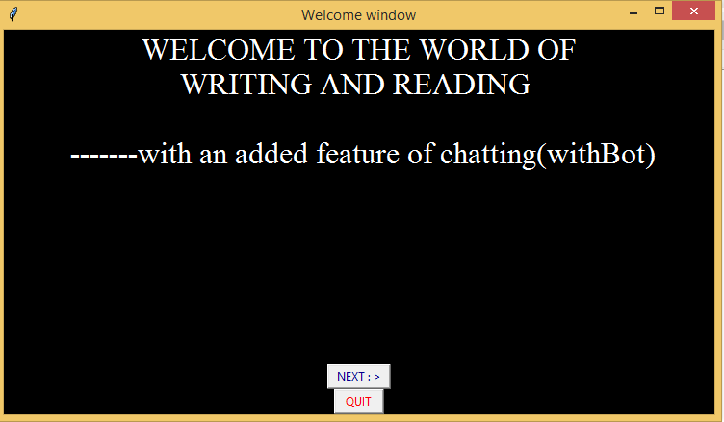

* **Sign up window**

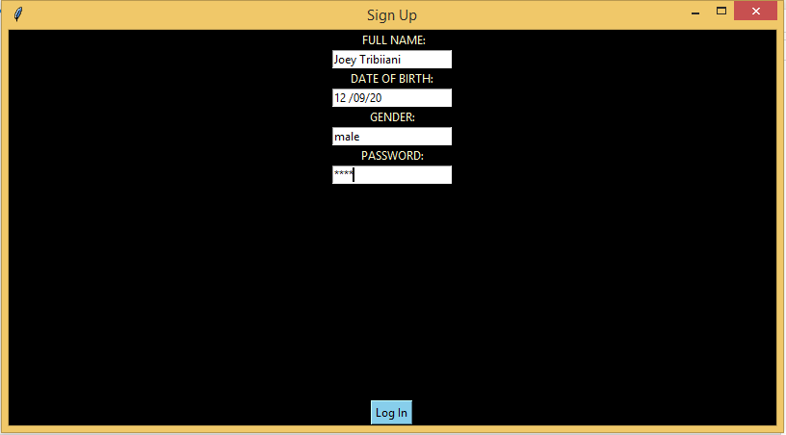

* **When clicked on log in button**

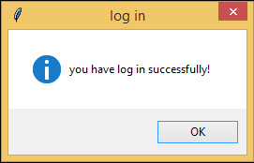

* **Menu window**

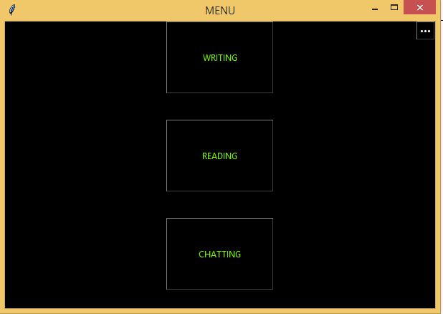

* **When Clicked On Button ‘**Screenshot (75).png**’ Given In**

**Menu Window**

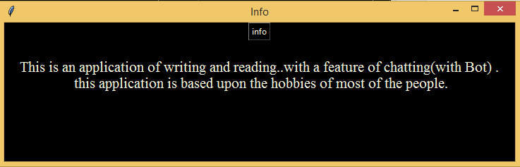

* **Writing Welcome**

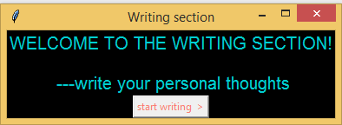

* **When clicked on start writing button**

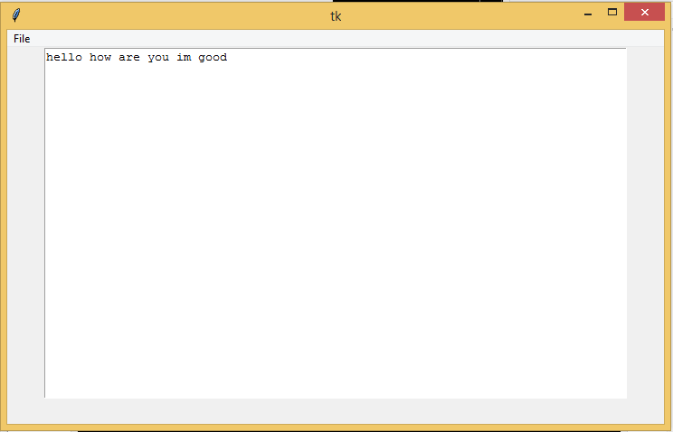

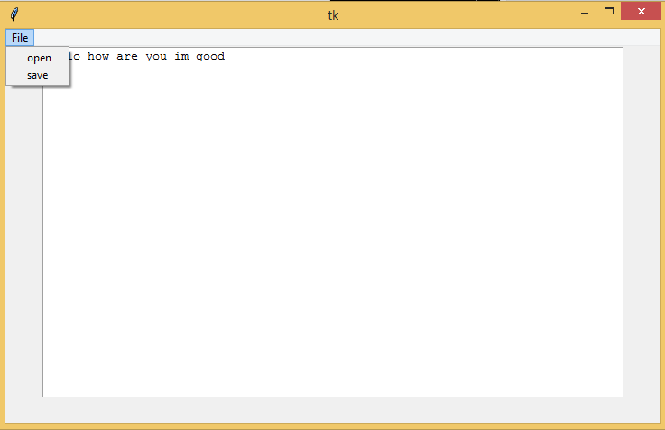

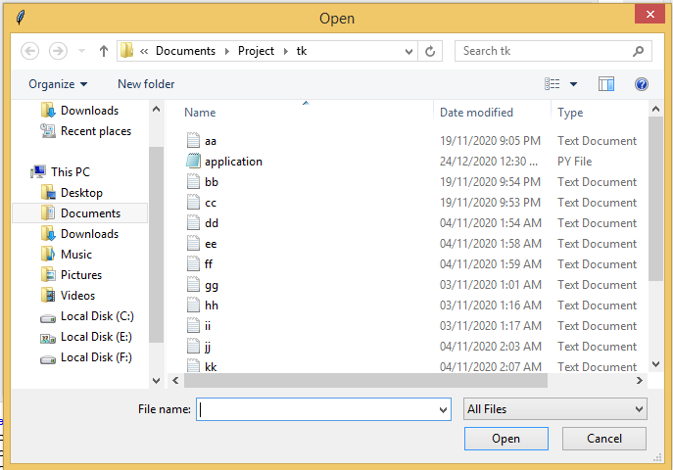

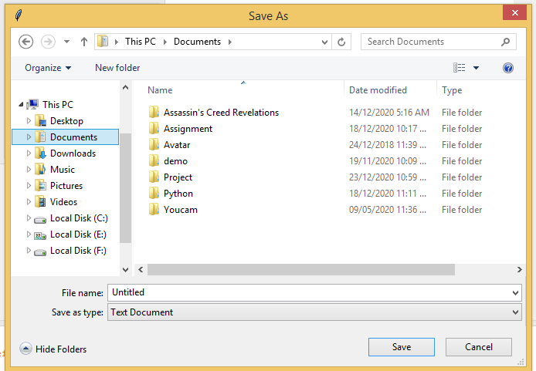

* **READING WINDOW**

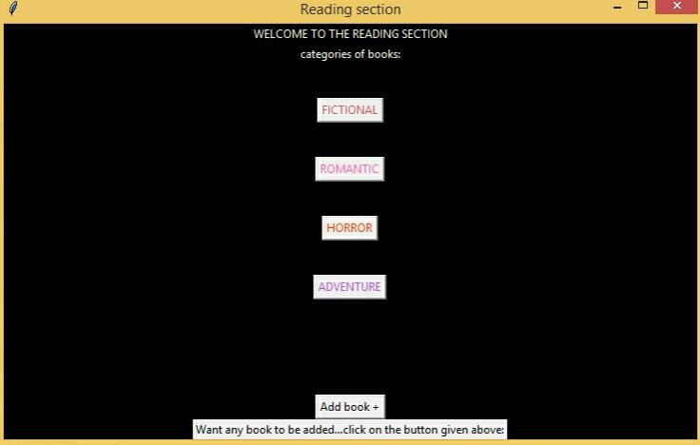

* **When clicked on button “Add Book+”**

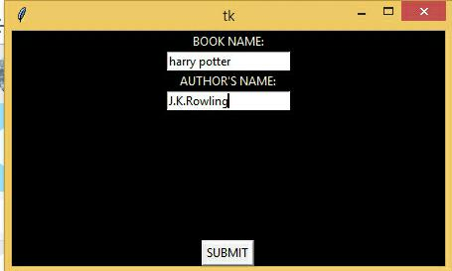

* **When clicked on submit**

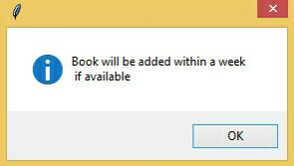

* **Fictional books**

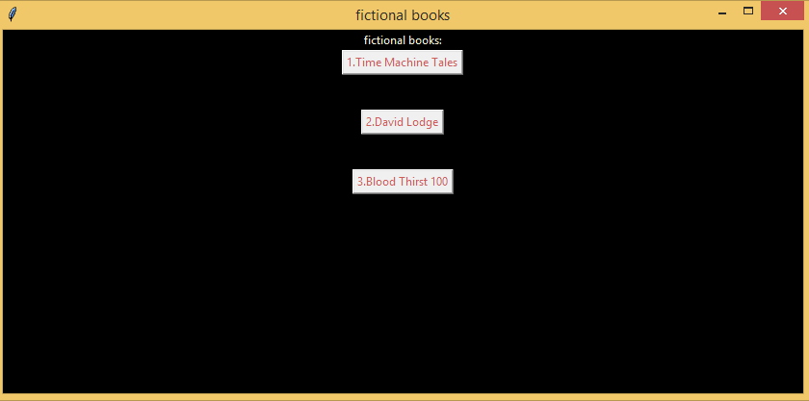

* **An example of fictional book**

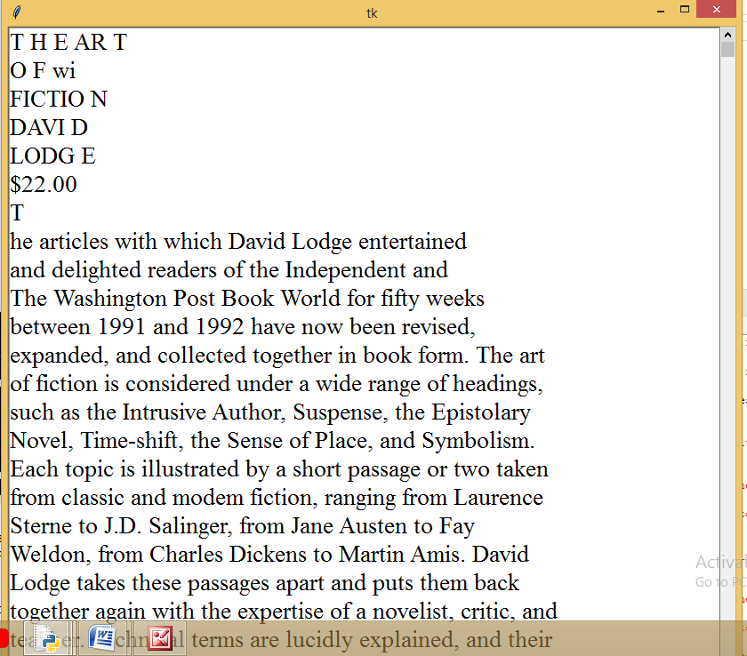

* **Text file of the book**

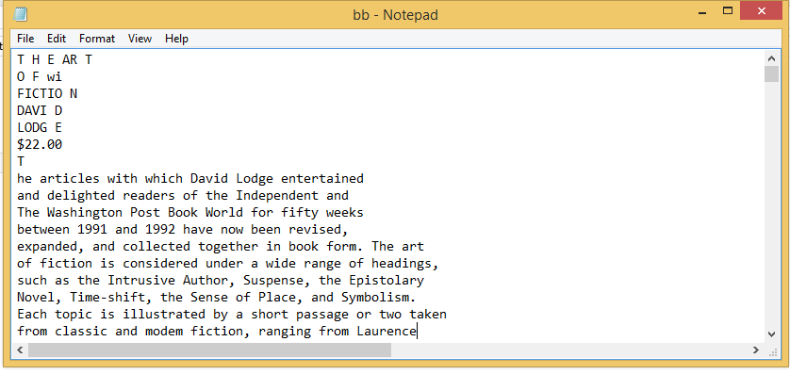

* **Romantic books**

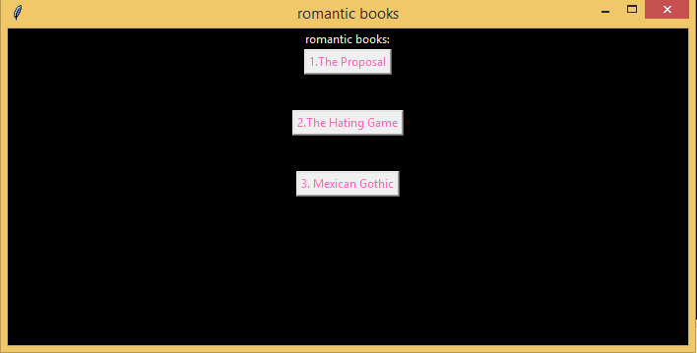

* **Horror books**

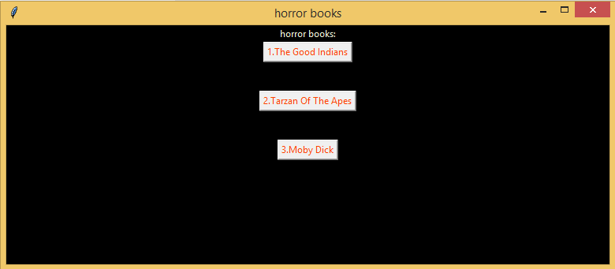

* **Adventures books**

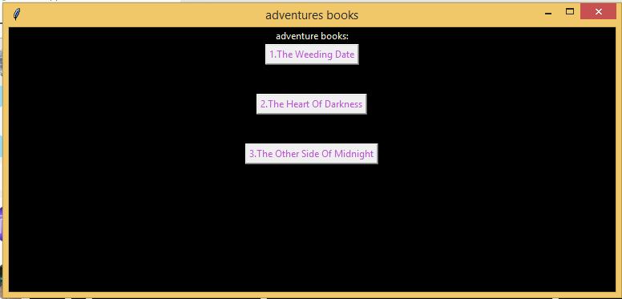

* **Chatbot window**

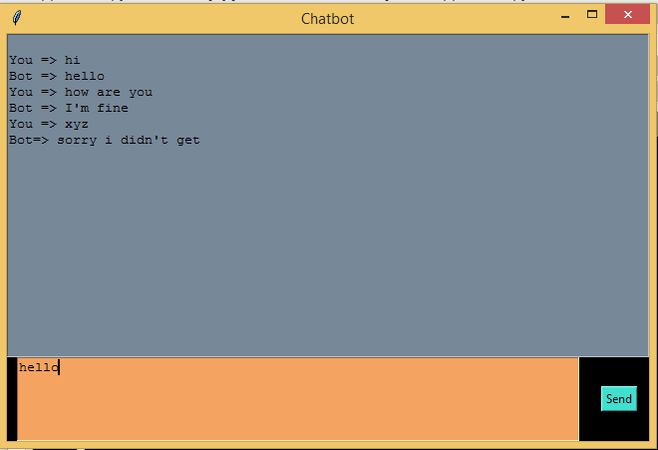

* 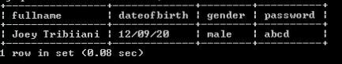**SQL tables**



**CONCLUSION**

We have learnt a lot about the application of Python and MySQL throughout the process of finalizing this project .We have gained more knowledge about Tkinter , MySQL connector and file handling.

It was a great experience and journey in making this project in a group , which helped us to develope team management skills.

In this project we intended to apply our concepts which we had learnt in class to make an user – friendly application .

**BIBLIOGRAPHY**

* www.google.com
* www.geeksforgeeks.com
* www.stackoverflow.com
* www.youtube.com
* Computer Science with Python by Sumita Arora (class 12th)